2116 Infographic Inquiry 4 points Due T Aug 9, 2022 11:59 pm

Learning Objectives:
- Research a technical communication topic
- Analyze and organize content information for a specific audience and situation
- Design a visual representation of content through an infographic

This project asks you to research, analyze, critique, apply, and present a technical communication topic of your choice. Infographics are a visual way to represent a topic/information through visuals, data, and short organization content sections.

What is an Infographic?
You are probably familiar with this genre but maybe did not know the official name. An infographic is a collection of imagery, charts, and minimal text that gives an easy-to-understand overview of a topic. This project then asks you to critically read, think, and organize the content you have to determine main idea, examples and visuals/data to represent your topic. Infographics tell a story with a title, headings, introduction, body, and conclusion through visuals/data with minimal text. Infographics come in a variety if styles and formats.

Your Audience is someone not familiar with the topic or the topic research.
The Situation/Context can be any area the reader/audience would come across your infographic while reading/researching your topic. Ex. A website, a magazine/newspaper article, a news report, etc.
Your Purpose is to educate, inform your audience about your topic.

This site will give you many examples of infographics https://www.dailyinfographic.com/

Why are Infographics Important?
Infographics present content in a new visual manner to help readers gain the content and understand the concept without reading a large amount of material.

https://venngage.com/blog/what-is-an-infographic/#2

https://www.creativebloq.com/infographic/tools-2131971

http://www.instantshift.com/2011/03/25/what-are-infographics-and-why-are-they-important/

https://www.nngroup.com/articles/designing-effective-infographics/

https://www.linkedin.com/pulse/20140623221710-7633856-your-brain-on-infographics-the-psychology-behind-why-they-work

https://www.tandfonline.com/doi/full/10.1080/1051144X.2016.1205832

https://www.researchgate.net/profile/Waralak_Siricharoen/publication/256504130_Infographics_the_new_communication_tools_in_digital_age/links/0c9605232e6f666b1f000000.pdf?disableCoverPage=truehttp://www.researchgate.net/profile/Waralak_Siricharoen/publication/256504130_Infographics_the_new_communication_tools_in_digital_age/links/0c9605232e6f666b1f000000.pdf?disableCoverPage=true

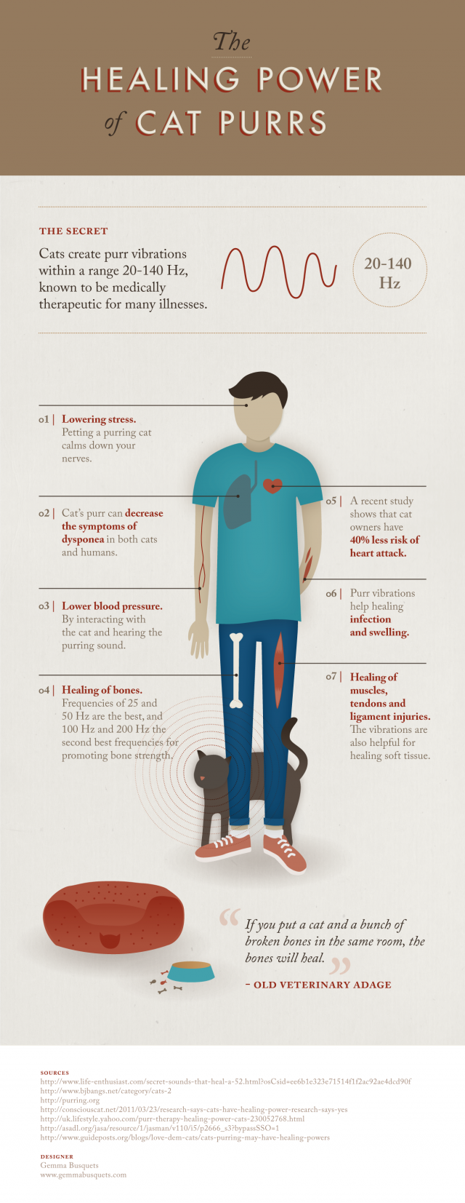
How Do I Make an Infographic?
There are many free online tools to create infographics. Some of the most common include:
- https://venngage.com/
- https://www.canva.com/
- https://piktochart.com/
You are not limited to these sources, so it is fine if you want to create your infographic using a different source.

How Do I Choose a Topic Idea? pick some aspect of a technical communication topic that interests you that you want to know more about: ethics, design, layout, technology, copyright. Email, internet security, accessibility, diversity, cultural considerations, writing process, workplace documents, teamwork, challenger space shuttle, business communication, organizational culture, country culture, internet advertisement, web 2.0, any technology advance, instructions design, color choice, oral presentation tips, medical technical communication, résumé, design, history of instruction manuals, business cards, etc

These two sources provide many examples of technical communication topics that you can explore:

https://idratherbewriting.com/2010/09/10/40-foundational-books-for-technical-writing/

https://www.google.com/search?ei=Xwn1XJ_FBcSa_QbDnaj4Aw&q=technical+communication+textbooks&oq=technical+communication+textbooks&gs_l=psy-ab.3..0j0i22i30l7.6085.8002..8675...0.0..0.95.555.9......0....1..gws-wiz.......0i71.Wme9QpPs6rU

How Do I Research?
Possible Sources: Journal of Technical Communication, Technical Communication Quarterly, Journal of Business Communication, EBSCO Host, NCLive, credible websites/news sources, GoogleScholar
- Locate sources
- Gather relevant interesting content
- Critically read and analyze content
- Determine what you want to say about your topic
- Organize concepts
- Choose relevant visuals/data
- Consider design elements such as layout, color, font
*Include sources at the bottom of the infographic*

Scoring Guide 4 points Due T Aug 9, 2022 11:59 pm
- Interesting and thoughtful content
- Quality reliable sources
- Well organized
- Good use of design elements- color, font, white space, headings, etc.
- Correct grammar, sentence structure variety, word choice (as appropriate)
- Tells a story
- Visuals/data/text are all cohesive and complement each other

There is no specific length but the content/visuals/text should have enough substance that the reader learns about your topic and the amount of content indicates that you have researched and learned about the topic .

